### **Environment Setup Documentation for BigQuery SQL Analysis**

#### **Tools and Software Used**

**- Google BigQuery:** Used for storing and querying large datasets using SQL.

#### **Setting Up BigQuery Environment**

**1. Google Cloud Project:**

- Create a new project in Google Cloud Platform (GCP) by navigating to the [Google Cloud Console](<https://console.cloud.google.com/>).

- Click on "IAM & Admin" in the sidebar, then "Create a Project". Name your project (e.g., `Target Brazil Analysis`), and note the project ID.

**2. Setup BigQuery:**

- From the Google Cloud Console, go to the BigQuery service.

- Create a dataset by clicking on your project name, then "CREATE DATASET". Provide a dataset ID (e.g., `target_brazil`) and set data location preferences.

**3. Creating Tables:**

- To create tables, click on the "More options" button in your project. There, you'll find an option labeled "Create table." Click on this option, and you will be presented with multiple methods to create tables. Since we already have the CSV files, choose the "Upload" option. As shown below.

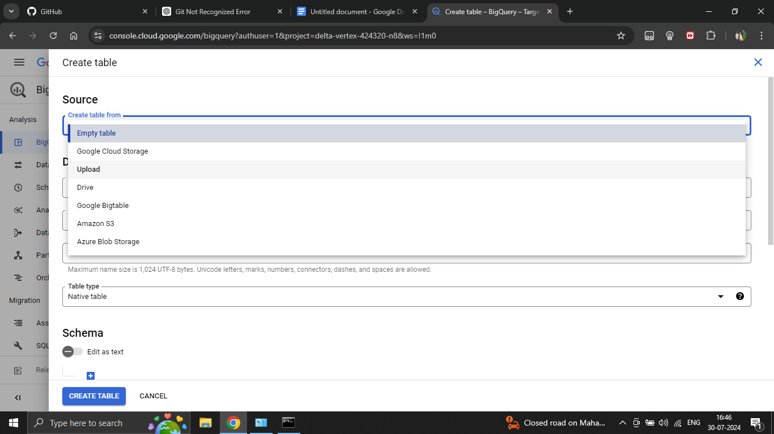

- You can browse for the file by clicking on the "Select file" option. After selecting the file, you need to name the table in the "Table" field. Choose the "Auto detect" option for the schema. Finally, click on "CREATE TABLE." Your table is now ready in BigQuery. Repeat these steps for any other tables you want to create. Now, you're ready to play with your tables. It looks as shown in below.

